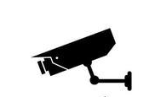

Network HD Camera User Manual

202003 Version

目录
2. Connector Instructions 3
3.Function Usage Instructions 4
1.1 Network Connecting Diagram 4
1.2 Network Configuration 4
1.2.1 Browser Setting 4
1.2.2 Logon Interface 5
4.3Realtime preview 6
1.4 Digital Zoom 6
1.5 Other Functions 7
1.6 Parameter Configuration 7
1.6.1 Device Information 7
1.6.2 Time Setting 8
1.6.3 Audio Setting 9
1.6.4 Voice Alarm Output 10
1.6.5 Alarm Light Output 10
1.6.6 Display Setting 11
1.6.7 Encoding Setting 12
1.6.8 Image Parameter 12
1.6.9 Motion Detection 14
1.6.10 Privacy Alarm 15
1.6.11 Privacy Mask 15
1.6.12 Humanoid Detection 16
1.6.13 Network Setting 17
1.6.14 HTTP/HTTPS 17
1.6.15 RTSP Setting 17
1.6.16 Multi-broadcast configuration 18
1.6.17 User Management 18
1.6.18 Auto Maintainance 19
1.6.19 Restore default 19
1.6.20 Local Setting 19
1.6.21 Developer option 20
1.7 File Management 20
1.8 Exit System 20

- Safety Precautions
To prevent danger and prevent property damage, please read this instruction carefully and strictly observe it before use. If you are installing this equipment in a public place, please give notice in a prominent place: "You have entered the electronic monitoring area"

Warning

During the installation and use of the equipment, please strictly follow the installation requirements. The company will not be liable for any damage to the equipment that has not been installed in accordance with the installation requirements.
During installation and use of the equipment, strictly observe local electrical safety standards and use the power adapter marked with the LPS standard, otherwise it may cause damage to the machine.
Please use the accessories included with the product. The equipment supply voltage must meet the input voltage requirements of the equipment.
The equipment is installed in unstable voltage areas and needs to be grounded to release surges and other high energy to prevent the equipment from being burned out.
When using the device, do not allow water or any liquid to flow into the device. If liquid accidentally flows into the device, immediately disconnect the power and remove all cables (such as power cables and network cables) from the device.
Do not focus the device on strong light (such as lighting, sunlight, etc.), otherwise it may affect the life of the image sensor. The equipment is installed in areas where there is frequent lightning, and it needs to be grounded nearby to release high energy such as lightning and prevent equipment damage.

Caution

During transportation and storage, heavy pressure, severe vibrations, and soaking are required to prevent damage to the product.
Do not drop the device on the floor or be strongly knocked, and keep the device away from places where magnetic interference exists, and avoid installing the device on a surface that is subject to shock or shock.
Please use a soft, dry cloth to clean the body. If dirt is difficult to remove, wipe it off with a dry cloth, and gently wipe it with a small amount of neutral detergent. Then wipe it dry.
Do not block the vents. When installing the device, pay attention to the manufacturer's installation instructions.
Do not place the machine near heat sources such as radiators, heaters, or other heat-generating equipment.
Please do not place the machine in humid, dusty, hot, cold, strong electromagnetic radiation and other places.
When the equipment is installed outdoors, please be sure to take measures against insects and moisture to avoid corrosion of the circuit board and affect monitoring.
If you do not use it for a long period of time, unplug the device.

Special Notes:
The whole product that our company sells, after passing our strict inspection, after the inspection is ex-factory, the product is accompanied with the nameplate, the quick operation manual and the attachment and so on.
All products that are not manufactured or counterfeited by our company are not responsible for all the resulting liabilities.
Our company will update the content of this manual according to the enhancement or change of product features, and will regularly improve and update the hardware and software products described in this manual. The updated content will be added in the new version of this manual without notice.
This manual may contain technical inaccuracies, or inconsistencies with product features and operations, or typographical errors, which are subject to the company's final interpretation.
The content of this manual is for users only, it does not guarantee that it is completely consistent with the actual object. Please prevail in kind.

Connector Instructions
1、Power port：DC12V
2、Audio Input：MIC Port（MIC IN）（G.711U compression standard）。
3、Audio Output：Audio output signal（AUDIO）（G.711U compression standard）。
4、Network Port：Support ONVIF 2.0 protocol, Ethernet（RJ45，10/100M), support TCP/IP、UDP、HTTP、RTSP protocol IE, POE, video code format is H.265.

3.Function Usage Instructions

Network Connecting Diagram
There are two kinds of connection between IP camera and computer, connect ipc to computer directly trhough RJ45 network cable, or connect IPC to computer through switch, refer to following picture:
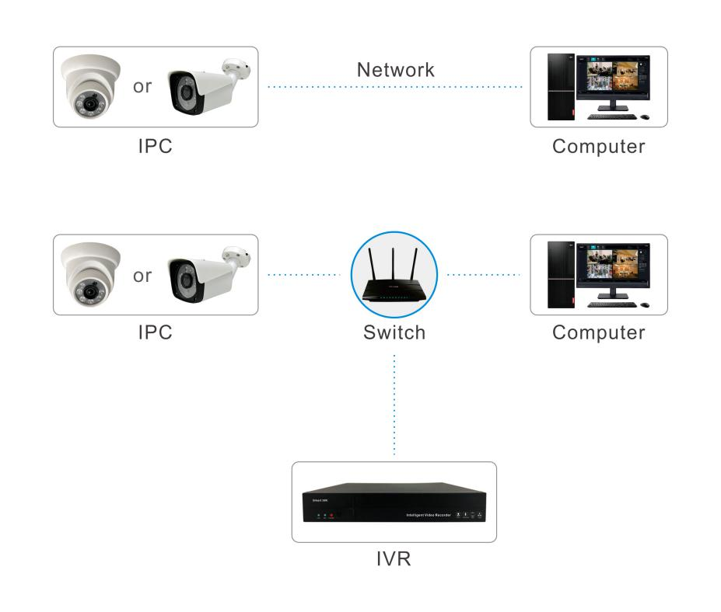

Note：
- IPC default IP address is“192.168.1.188”, Port is“80”, user name:“admin”;
- IPC gateway must be the same with computer gateway;

Network Configuration

Browser Setting
After finish hardware installation, it is necessary to preview camera parameters and set the relevant parameters. The following describes the relevant configuration of entering control interface through IE browser.
Note: When preview camera images through IE browser, user needs to set the browser security level to facilitate the installation of plug-ins.To open IE browser, enter into menu[tool/Internet option/Security/definition...],user need to modify setting of ActiveX control software and plugin”on computer, refer to following pictures. For the sake of safe, user needs to make IE browser security level default after user preview image.
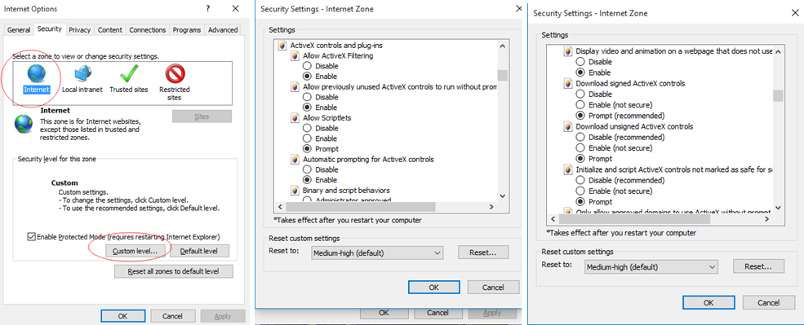
IE Security Level Setting
Note:
- In order to avoid to fail to install plugin, advise user to delete all history recording in IE browser, operation as follows: enter menu[ tool/internet optional/routine/delete/ need to choose all except for "keep favorite website data”], then click delete
- Need to operate IE browser through using administrator.

Logon Interface
To input IPC IP address on IE browser( default IP address 192.168.1.188) to login.
When user login at the first time, user needs to install plugin, to click hint to download plugin and install ActiveX control software, refer to following picture.
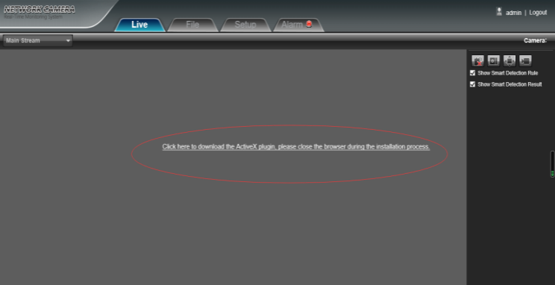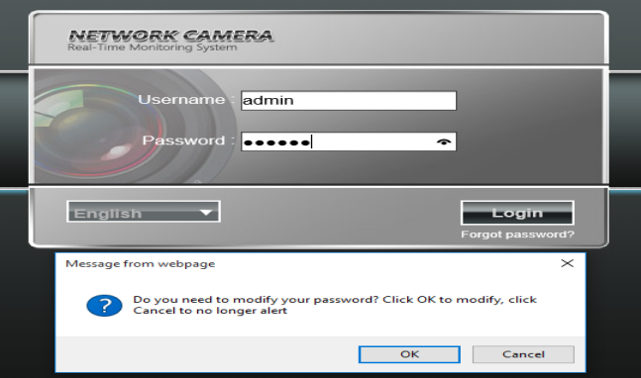
After finishing installing it, default user name is admin, password is 123456, then click “logon”, it will pop up hint” whether change password or not”, confirm it, user can set up password at willing, refer to following picture.
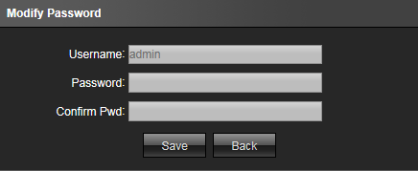
After finishing setup new password, user can login landing interface, refer to following picture:
User name：admin（default）
Language: choose Chinese or English, then logon.
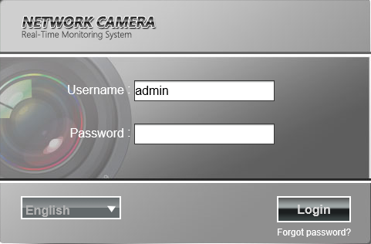

4.3Realtime preview
After logon interface, user can go to preview interface, refer to following picture:
Note: Device with TF card is full function display interface, otherwise it is simplicity display interface
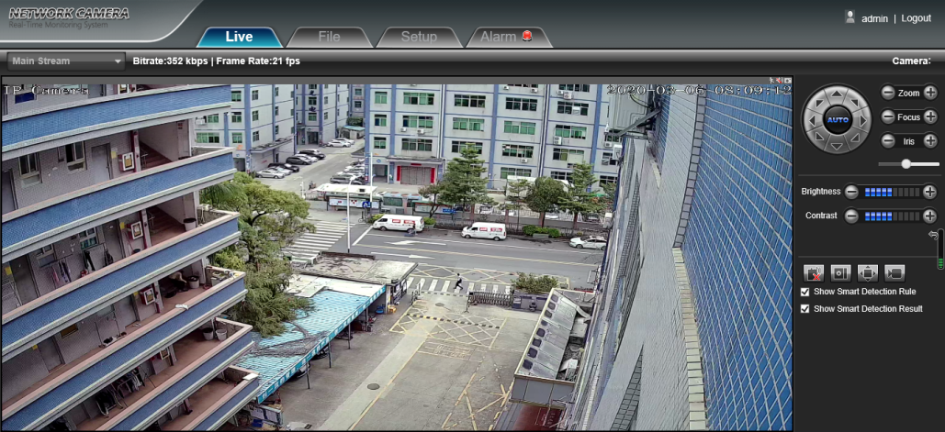

Preview in full screen: to click full screen icon or click mouse right key one time on preview window, click mouse right key one time on preview window or click ESC on keyboard to exit full screen mode.

Digital Zoom
To use mouse to choose preview interface which need to be zoom, then scroll mouse, refer to following picture:

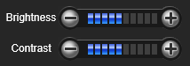
Other Functions
- Brightness:Adjust picture brightness.
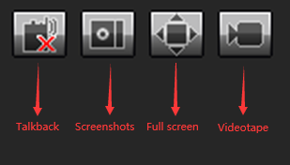
- Contrast:Adjust picture contrast.
The icon is to make parameter default
- Intercom：To click “turn on/Off” remote intercom
- Capture:Preview captured image, to click icon will pop up saved file path.
- Full screen: Display image in full screen
- Recording: Turn on/off preview image recording.
- Schedule style: Turn on/off front end alarm
（Note：red X means turn off or prohibited）

Parameter Configuration
The following picture is configuration interface, left list is parameter setting mode, the configuration information for each mode is different, will explain them one by one:
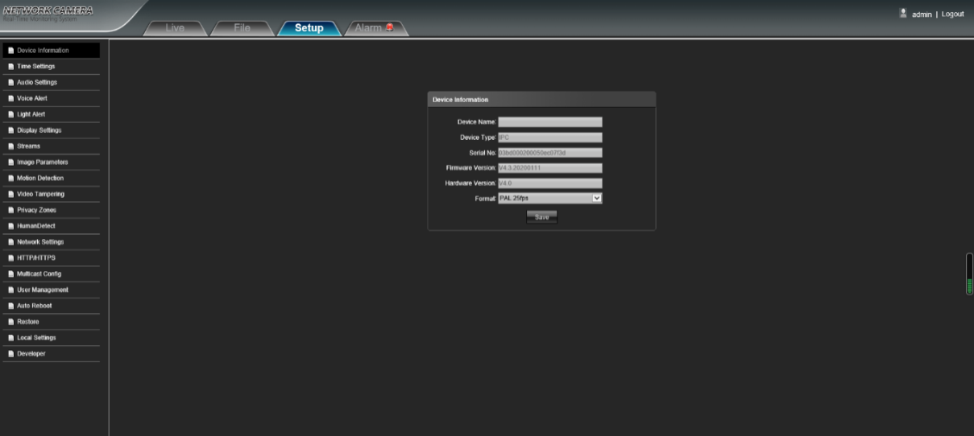

Device Information
The interface of IP Camera device information looks like following picture:
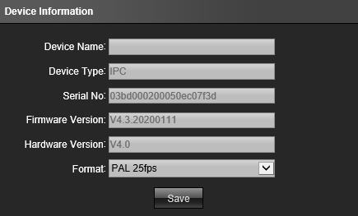
    - Device Name: configure device name
    - Device Style: Display device style, not allow to modify
    - Series Number: Display product’s series number, not allow to modify
    - Software Version: Display software version date, not allow to modify
    - Firmware Version: Display motherboard version, not allow to modify
After finishing configuring setting, to click”save”,then it would be valid

Time Setting
It is mainly divided into three parts: time setting, NTP setting and summer time
setting.
IP Camera time interface like following picture:
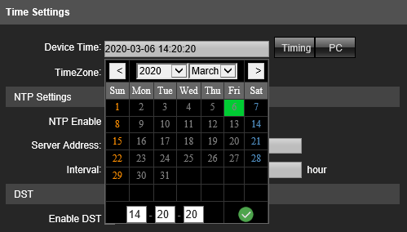
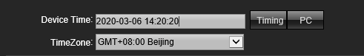
- Calibrate Time: Choose device time, click”calibrate time” to save it
- PC: IP Camera NTP interface like following picture:
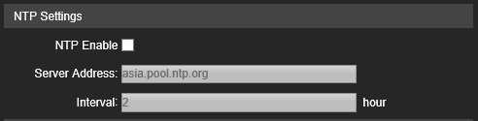
To choose NTP and input server, user can adjust time interval according to requirement, then click”save”.
Note: Turn on NTP, configurated time would be invalid.
IP Camera daylight saving time like following picture:
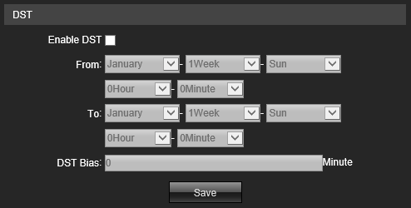

- Turn on summer time: to run or turn off it, if it is in the area of summer time, to click” ” it is ok.
- Summer time starting time: Set up summer time starting time
- Summer time ending time:Set up end time
- Offset time: configure offset time of summer time,threshold value 0-720 Minutes.
After finishing setting parameter. To click”save” icon, the setting would be valid.

Audio Setting
IP Camera audio setting like following picture:
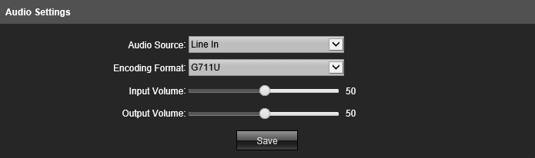
- Audio source: to choose audio input method, line in or MIC two modes.
- Encoding format: default G711U
- Input voice volume: set up input voice volume, ranges from 0 to 100, default is 50
- Output voice volume: set up output voice volume, ranges from 0-100, default 50
After finishing setting parameters, to click”save” icon, it would be valid.

Voice Alarm Output
IP Camera voice alarm output interface as follows:
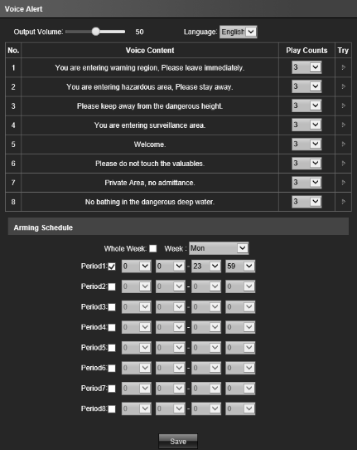
- Output audio: audio 0-100 adjustable, default 50
- Language: Chinese and English
- Try to listen: broadcast default voice content
- Correction: modify audio file name
- Broadcast time: set voice alarm broadcast time
- Week: set arm time from Monday to Sunday
- Arm time: Set voice alarm time
After finishing setting parameters, click”save” icon, it would be valid.

Alarm Light Output
IP Camera flash alarm light output configuration interface as follows:
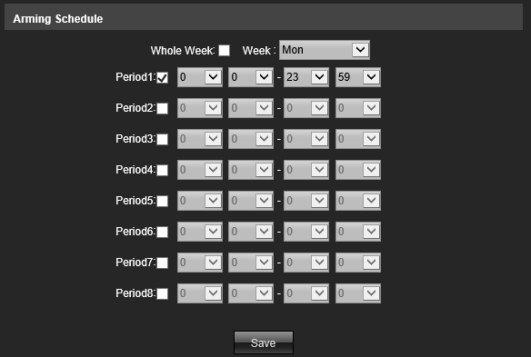
- Week：Set arm time from Monday to Sunday.
- Arm time: set arming time, can set 8 time ranges one day
After finishing setting parameters, to click”save” icon, it would be valid.

Display Setting
IP Camera display setting interface as follows:
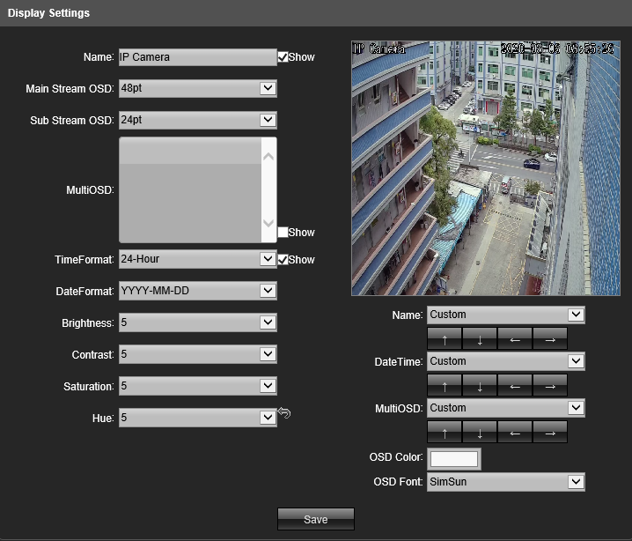
- Title: to change IPC name
- Main/Sub stream code OSD: adjust main/sub stream code interface OSD font size.
- Multi-line OSD: set multi-line OSD information
- Time/Date format: to choose different time/date format.
- Brightness/Contrast/Saturability/Chroma: adjust brightness/contrast/saturability/chroma
- Title position/date adjust: click these four icons and “left above corner”/“right above corner”,“left down corner”“right down corner”, to move position of title and date displayed on preview image
- Color gain: change font color.
- OSD font: change font theme\
After finishing setting parameters, to click”save” icon, it would be valid.

Encoding Setting
IP Camera encoding setting interface as follows:
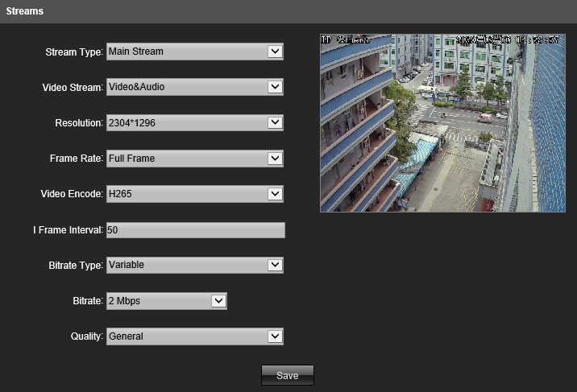
- Code Compression style: Main stream code(time) or sub-code( transfer on internet) two styles
- Stream Code Style: including composite stream and video stream
- Resolution: display resolution of the camera
- Video frame: user can set frame/second from 1 to 25 / 30 in PAL/NTSC of device information, full frame P=25 fps or N=30 fps
- Encoding Style: including H.264/H.265 encoding style
- Iframe interval: set I frame interval value, default is 50
- Bit rate style:including fixed stream code or variable stream code
- Bit rate: set different rate according to requirement(Note: The factory default bit rate shall prevail)。
After finishing setting parameters, click”save” icon, it would be valid immediately.

Image Parameter
IP Camera image parameter configuration interface as follows:
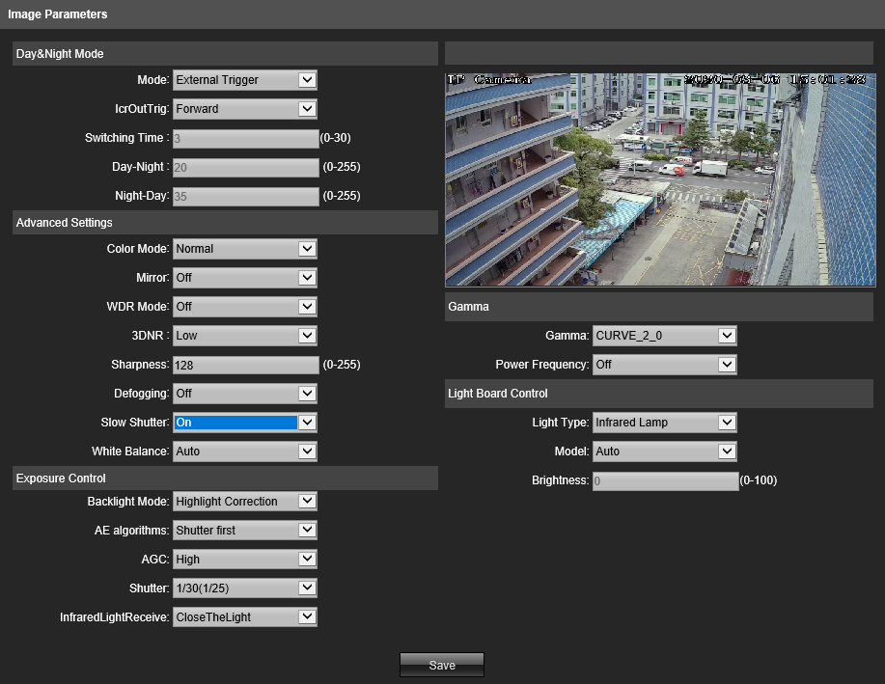
- D&N switch: trigger/auto/color/B&W. non-infrared IPC switch mode is auto, infrared IPC switch mode is external trigger, user can switch according to ip camera style and usage environments.
- Swtich Time: D&N switch delay value default is 3 seconds
- D&N switch threshold: default is 20, threshold ranges is 0-255.
- Night switch threshold: default is 35, threshold range is 0-255.
- Color mode: standard/natural/colorful, color mode default is standard
- Mirror: Off, horizontal mirror,vertical mirro,180 degree flap four modes, default mode is 180 degree flap, setting would be valid immediately
- WDR: off/digital WDR, default is OFF
- 3D time area:Off/low/middle/high/higher four levels, 3D time area default is low level
- Sharpness:0-255 adjustable, default is 128
- Defog function: Off/Low/Middle/High, default is OFF
- Reduce frame at night: On/Off, default is OFF
- White Balance: Auto/definition/blocked WB/white light/yellow light/natural light/fluorescent lamp.
- Backlight mode:Off/Strong light suppression/BLC. Default is Off.
- Backlight level: default is 5, threshold range is 1-10.
- Target brightness: default value is 50, threshold range 1-100.
- Exposure distribution strategic: Gain prior and exposure prior.
- Gain Control: it is set under auto exposure mode, Low/High, auto gain value is high by default, the more the auto gain value, the more sensitivity under low illumination, but noise would be obvious.
- E-Shutter: it would be set under manual exposure mode, range is 1/5-1/100000。
- Gamma: There are four modes, such as CURVE_1_6，CURVE_1_8，CURVE_2_0，CURVE_2_2 ,Gamma default is CURVE_2_0。
- Power frequency: Off, 50HZ，60HZ three modes, default is off.
- IR light control mode: There are three modes, off/manual/auto, default is auto（Note: IPC without adjustable light has not this funciton）, IR light is not controlled under off mode, IR light would be OFF
- Manual mode: adjust IR light brightness through changing parameters, range is 1-100, the more the value, the more the brightness of IR light
- Auto mode:IP camera will adjust ir light brightness through gaining image brightness, exposure and gain to realize excellent image and power is min
- Brightness:user can adjust IR light brightness under its control mode is mode, range is 0-100.
- IR light style: Infrared/Yellow/White light
After finishing setting parameters, to click”save”, it would be valid.

Motion Detection
IP Camera motion detection setting interface as follows:
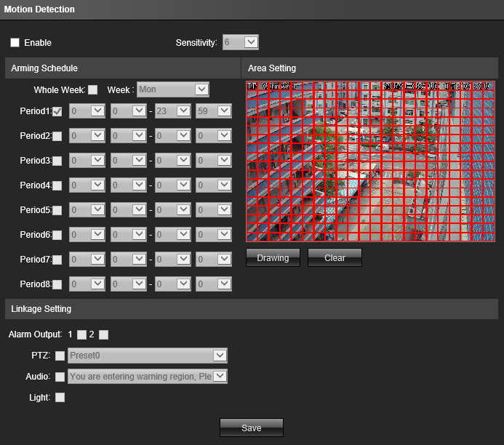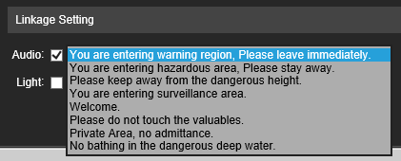
- Enable: disable or enable this function
- Sensitivity: the more the sensitivity,the more obvious the motion detection
- Week: set arming time from Monday to Sunday
- Arming time: set arming time range, 8 time ranges for one day
- Starting image: to keep pressing mouse left key to draw area of detection on”setting area” preview interface.
- Clear: to click”clear” to clear setting area
- Audio linkage: turn on audio linkage, it will sound after triggering alarm
- Alarm Light: set alarm light to remind after trigger
After finishing setting, click”save” , setting would be valid.

Privacy Alarm
IP Camera privacy mask alarm setting interface as follows:
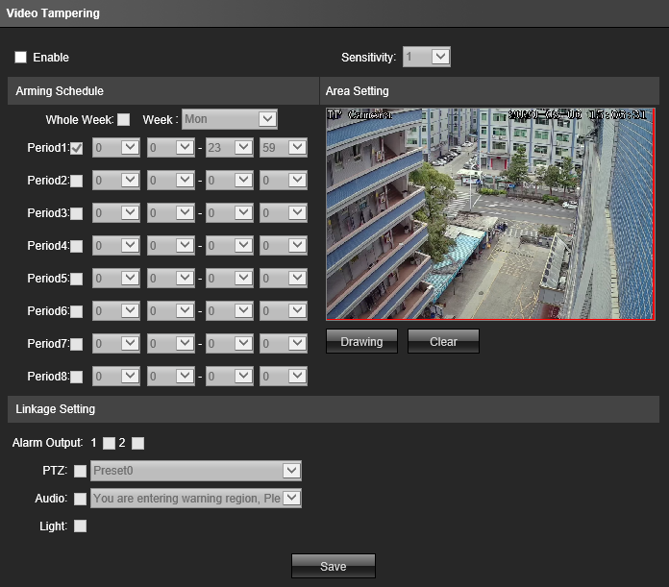
- Enable: disable or enable it
- Sensitivity: the more the sensitivity, it is more easy to trigger alarm
- Week: set arming time from Monday to Sunday
- Arming time: set arming time range, 8 time ranges for one day
- Starting Image: to keep pressing mouse left key to draw area of privacy mask on”setting area” preview interface.
- Clear: to click”clear” to clear setting area
- Audio linkage: turn on audio linkage, it will sound after triggering alarm
- Alarm Light: set alarm light to remind after trigger
After finishing setting parameters, click”save” icon, setting would be valid.

Privacy Mask
IP Camera privacy mask setting interface as follows:
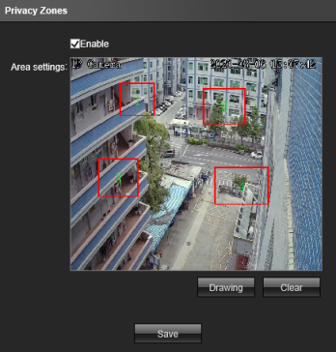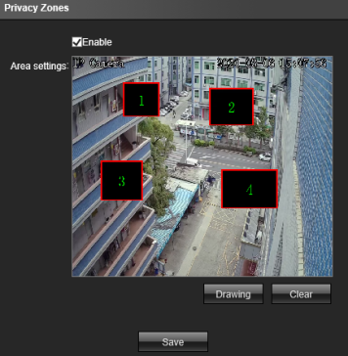
- Enable: Enable or disable this function
- Setting area: To keep pressing mouse left key to draw privacy mask area, max support 4 areas.
- Clearance: click”clear” to clear areas
After finishing setting, click”save”, it would be valid.

Humanoid Detection
IP Camera humanoid detection configuration interface as follows:
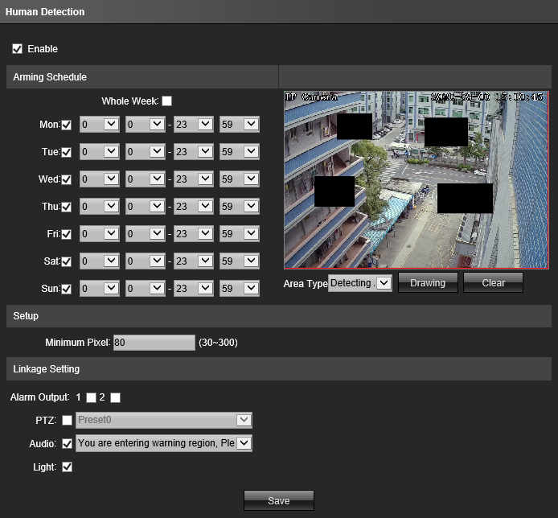
- Enable: enable or disable this function
- Detection area: max support 4 detection area
- Week: set arming time from Monday to Sunday
- Arming time: set arming time range, 8 time ranges for one day
- Min humanoid pixel: range is 30-300, IPC will detect humanoid pixel which is more than or equal to min humanoid pixel(blue frame)
- Set detection area: to use mouse to click area which would be drew line on channel picture, to keep pressing mouse left key to move to any direction, it would be formed red frame, frame size is decided by user, if it is not ok, user can erase, then reset it, operation is the same for setting privacy area and detection area. （Note: if privacy area overlaps with the detection area, the privacy area would be prior effect）
- Audio Linkage:turn on audio linkage, it will sound after triggering alarm.
- Alarm Light: set alarm light to remind after trigger
After finishing setting parameters, click”save” icon, setting would be valid.

Network Setting
IP Camera network setting interface asfollows:
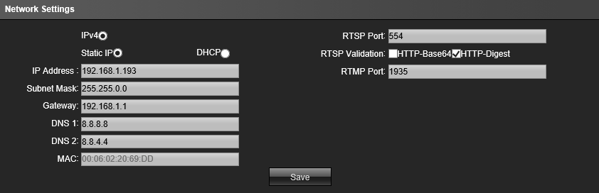
- IPV4：IP protocol version is 4。
- Static IP：Device IP address is fixed, default is 192.168.1.188。
- DHCP：If router enables DHCP, IPC will get IP address automatically from router.
- IPaddress: Input relative number to change IP address
- Subnet mask：Input relative IP subnet mask
- Gateway address: input relative gateway address
- Preferred DNS: DNS server IP address
- Alternative DNS : DNS server alternative IP address
After finishing setting parameters, click”save”icon, it would be valid immediately.

HTTP/HTTPS
IP Camera HTTP/HTTPS setting interface as follows
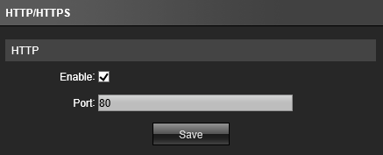
Default HTTP port：80
After finishing setting parameters, click”save” icon, it would be valid immediately.

RTSP Setting
IP Camera RTSP setting interface as follows:
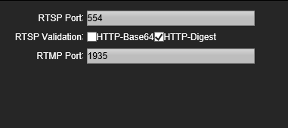
- RTSP Port：default 554。
- RTSP varification：enable or disable HTTP-Base64、HTTP-Digest varification, default mode is”enableHTTP-Digest”.
After finishing setting parameters, click”save” icon, it would be valid immediately.

Multi-broadcast configuration
IP Camera multi-broadcast setting interface as follows:
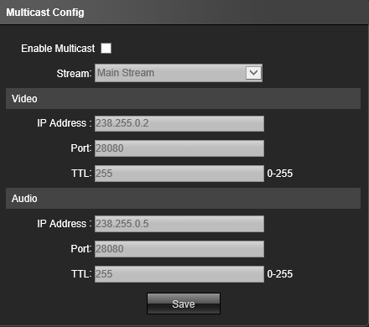
Default is “disable”, after enable it, user can set multi-broadcast main stream code, sub-stream code, and IP address, port and TTL of video and audio.
After finishing setting parameters, click”save” icon, it would be valid immediately.

User Management
IP Camera user management setting interface as follows:
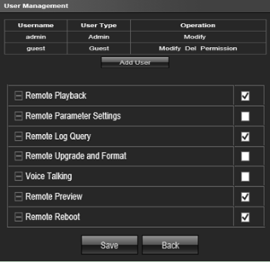
System default admin and guest two users,can change password for these two users, admin administrator user is not allow to delete, guest user is allow to be deleted,user can add new users according to requirements,and give them authorization,moreover, new user is allowed to be deleted.

Auto Maintainance
There are five modes on “auto maintainance” interface such as enable/everyday/every week/single time/every month, user can choose maintainance mode,the device will operate it automatically according to set mode and time.
IP Camera auto maintainance setting interface as follows:
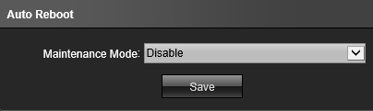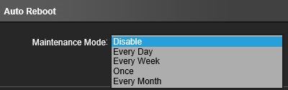

Restore default
IP Camera restore default setting interface as follows:
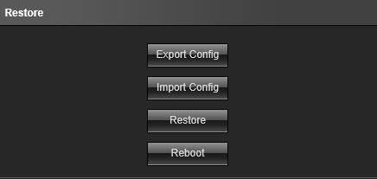
- Export configuration: export all configurations to PC or flash memory
- Import configuration: import files into system
- Restore default: restore factory default setting
- Restart: restart device immediately.

Local Setting
IP Camera local setting interface as follows:
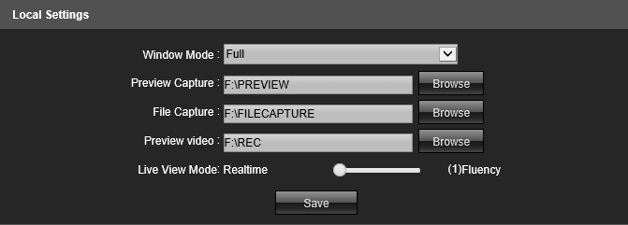
- Window mode: set display ratio of preview window( full/4:3/16:9 or original picture)
- Preview captured path:to modify saving path of preview captured image
- Playback captured image path:to modify playback captured image path
- File management captured image path: Modify the storage path of captured image of the file management video.
- Preview recording path: modify the storage path of preview interface recording
- Preview Mode: realtime mode and fluency mode, adjust their relative value
After finishing setting parameters, click”save” icon, it would be valid immediately.

Developer option
Note: default mode is disable, it was normally applied to remote debugging program, for the sake of safety, please do not enable this function.

File Management
To View the captured or recorded files and linkage captured files at the specified time saved in machine,refer to following picture:
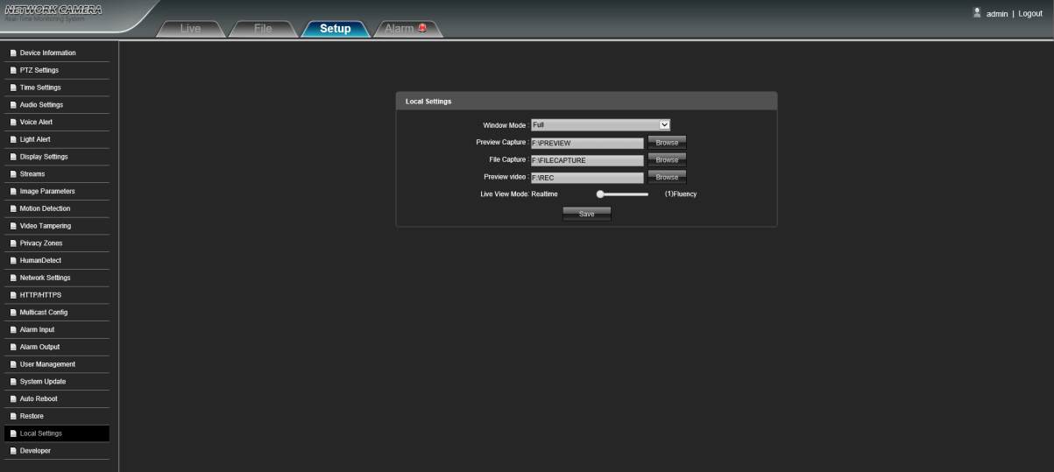
Note: IPC must support TF card function, to insert TF card will display files: when play recording , user can play Fast / slow / frame / capture...etc

Exit System
To click’exit”like following picture:
FAQ
- How to know IP Camera IP address?
- Method 1: default ip address is 192.168.1.188，user can logon IE through this IP address if user use it at first time
- Method 2: DHCP and ONVIF all network communication function are enabled by default( auto get IP address), if it is first time to connect to LAN or NVR, IP address would be changed, user can search ip camera address through VMS/CMS/NVR or upgrade IPC search tool, if it is first time to connect to NVR from the third party, IP camera IP address would be same gateway with NVR’s, nvr will search it directly.
- It will occur following abnormality when user logon IE
- It remind“404”error or “you can not visit website”
To check IP address right or wrong on IE address bar, correct format is http://192.168.1.188
To check ip camera connect to network or not, user can search IP camera through upgrade IPC search tool installed on computer, user make sure that searched IP address must be same gateway with computer’s gateway ( pls refer to instructions of upgrade IPC search tool)
- Can not download plugin or fail to open plugin download linkage
There are two types of download mode, such as local download and network hard disk download, if user can not open download interface, it means that download mode of the IPC is network HDD download, now the computer must be connect to ethernet, if it does not pop up download interface or open download page, it means network delay, please refresh it or wait a moment, download it again, if user still can not resolve it, please contact technicist.
It remind” does not install plugin without signature when user install plugin, my company ip camera plugin without company digital signature, IE browser will block to install plugin without signature by default, solution to the problem as follows:
Enable IE browser, open browser[setting]-[internet option] menu, like following picture:
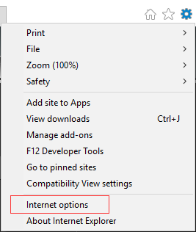

To turn off” enable protection mode” of [internet] and [local internet] in the list of security, to click and apply, refer to following picture:

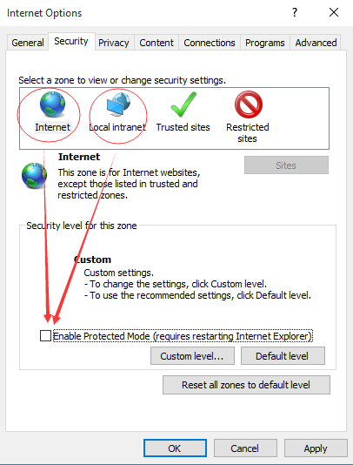
To enter “user-defined” menu of [internet]and [local internet], to choose “enable” starting from first “net framework” to “script”, then click to confirm, finally restart IE browser, visit IP camera again.

